**Internship Project Report on**

# A Project Based on UPS Contract Management System

A report submitted as a part of the industrial Orientation Training in

IT & ERP Department. Visakhapatnam Steel Plant

**By**

**G SANJIB (202224491)**

**A SONAL (202221110)**

# Department of Information Technology

Under the guidance of

K.N.S.S Yadav (DGM)

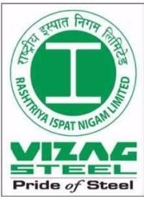

**RASHTRIYA ISPAT NIGAM LIMITED (RINL), Visakhapatnam**

(Duration: 9th June 2025 to 5th July 2025)

# CERTIFICATE

This is to certify that the allowing Students of **NIST UNIVERSITY, BERHAMPUR** are engaged in the project work sided

A Project Full Stack WEB 2.0 Development from 9th June 2025 to 5th July 2025

**G SANJIB (FRONTEND DEVP)**

**A SONAL (BACKEND DEVP)**

In partial Fulfilment of the degree **BACHELORS OF TECHNOLOGY** in **COMPUTER SCIENCE AND ENGINEERING** stream in **NIST UNIVERSITY , BERHAMPUR** is a record of Bonafide work carried out by an under the guidance and supervision during the period from 9h June 2025 to 5th July 2025

**Date:**

**K.N.S.S Yadav**

**Deputy General Manager (DGM),**

**IT and ERP Department,**

**RINL-VSKP**

**Place**: Visakhapatnam

**ACKNOWLEDGEMENT**

First of all, I thank God in words for his grace, who gave me the opportunity and strength to carry out this work. The success and outcome of this project required a lot of guidance and assistance from many people and we are incredibly privileged to have got this all along with the completion of our project.

I thank this opportunity to thank Mr. K.N.S.S Yadav, IT and ERP Department. Visakhapatnam Steel Plant for guiding me with is immense knowledge and helping me complete this project successfully.

I wish to express my sincere thanks to IT and ERP Dept. employees of Visakhapatnam Steel Plant for their valuable guidance in completing this project

# DECLARATION

I hereby that this project work entitled **A Project Based on UPS Contract Management System** is original and has not been submitted to any university or college before fulfillment of the requirements of any course of study or to the award of any degree. The opinion is given and the conclusions arrived at are of my own. The views expressed in the rep

**INDEX**

|  |  |  |
| --- | --- | --- |
| S.NO | CONTENTS | PAGENO |
| 1. | Abstract | 6 |
| 2. | An Introduction to VSP | 7 |
| 3. | Introduction About the project | 9 |
| 4. | Requirement Given for Project | 11 |
| 5. | Design Of Project And Database Schema | 15 |
| 6. | Conclusion | 24 |
| 7. | Reference | 25 |

**1. ABSTRACT**

This report describes the design and implementation of a **web-based UPS Contract Management System** developed to simplify and improve the management of Uninterruptible Power Supply (UPS) contracts, maintenance activities, and complaint handling. UPS systems are essential for ensuring uninterrupted power to critical infrastructure, and effective monitoring of their contracts and servicing is necessary to maintain system reliability. The proposed system replaces manual and fragmented processes with a centralized digital solution.

The application allows **authorized users** to perform **Create, Read, Update, and Delete (CRUD)** operations on UPS contract records, preventive maintenance (PM) schedules, breakdown complaints, and verification reports. Contract-related information such as vendor details, contract validity, and equipment specifications can be efficiently stored and managed. The preventive maintenance module supports scheduling and tracking of routine service activities, helping reduce unexpected failures and improve system longevity.

A dedicated **complaint management module** enables users to register breakdown issues, monitor their status, and document corrective actions. The system also includes **verification and approval workflows**, allowing supervisory authorities to review and validate maintenance and complaint reports, thereby ensuring accountability and compliance with contractual terms.

The system features a **user-friendly web interface** with role-based access control to ensure secure and controlled data access. Centralized data storage facilitates quick retrieval of historical records, supports reporting, and aids informed decision-making. Overall, the UPS Contract Management System enhances operational efficiency, improves maintenance tracking, and ensures timely resolution of issues, making it an effective solution for reliable UPS infrastructure management.

## **INTRODUCTION TO VSP**

**OVERVIEW:**

Visakhapatnam Steel Plant (VSP) is the integrated steel plant Rashtriya Ispat Nigam Limited in Visakhapatnam which is founded in 1971, VSP strikes every one with a tremendous sense of awe, wonder and amazement as it presents a wide array of excellence in all its facets in scenic beauty, in management and above all in product quality.

On the coast of Bay of Bengal and by the side of scenic Gangavaram beach, have risen tall and huge structures of technological architecture, the Visakhapatnam Steel Plant. But the vistas of excellence do not rest with the inherent beauty of location over sophistication of technology- they march ahead parading one aspect after another.

The decision of the Government of India to set up an integrated steel plant at Visakhapatnam was announced by then Prime Minister Smt. Indira Gandhi in Parliament on 17th January 1971. VSP is the first coastal based integrated steel plant of India is located, 16km west of city of destiny, Visakhapatnam, bestowed with modem technologies, VSP has an installed capacity of 3 million tons per annum of liquid steel and 2.656 million tons of saleable steel.

The saleable steel here is in the form of Wire rod coils, Structural, Special Steel, Rebar’s, Forged Rounds and etc. At VSP there emphasis on total automation, seamless integration and efficient up gradation, which result in wide range of long and structural products to meet stringent demands of discerning customers with India & abroad. VSP product meet exalting international

Quality Standards such as JIS, DIN, BIS, BS etc.

VSP has become the first integrated steel plant in the country to be certified to all the three international standards for quality (ISO-9001), for Environment Management (ISO) -14001) & for Occupational Health & Safety (OHSAS 18001).

The certificate covers quality systems of all operational, maintenance, service units besides purchase systems, Training and Marketing functions spreading over 4 Regional Marketing offices, 20 branch offices & 22 stock yards located all over the country. VSP by successfully installing & operating efficiently Rs. 460 crores worth of pollution and Environment Control Equipment and converting the barren landscape more than 3 million plants has made the steel plant, steel Township and VSP exports

Quality Pig Iron & Steel products Sri Lanka, Myanmar, Nepal, Middle East, USA & South East Asia (Pig Iron). RINL-VSP was awarded "Star Trading House" status during 1997-2000. Having established a fairly dependable export market, VSP plans to make a continuous presence in the export market.

VSP also places strong emphasis on research and development, continuous process improvement, and skill enhancement of its workforce to remain competitive in the global steel industry. The plant actively undertakes Corporate Social Responsibility (CSR) initiatives in education, healthcare, environmental sustainability, and community development for the welfare of surrounding regions. With a strong focus on energy efficiency, digitalization, and green steel practices, RINL–VSP continues to modernize its operations to meet future challenges while contributing significantly to national infrastructure development and economic growth.

**Different sections at the RINL VSP:**

* Coke oven and coal chemicals plant
* Sinter plant
* Blast Furnace
* Steel Melt Shop
* Continuous casting machine
* Light and medium machine mills
* Calcining and refractive materials plant
* Rolling mills
* Thermal power plant Chemical power plant
* Yard management

## **3. INTRODUCTION TO THE PROJECT**

At the UPS Contract Management System, our goal is to simplify and streamline the management of UPS-related contracts, preventive maintenance schedules, and breakdown complaints across organizations. This web-based platform provides a user-friendly interface and powerful backend features that help various departments effortlessly record, access, and manage data related to UPS services and operations.

We have created a website for automatically storing the data on UPS Contract Management System. We have used technologies for:

Frontend (HTML, CSS, JavaScript)

Backend (Node.js)

**HTML-**

The Hypertext Markup Language, or HTML is the Standard Markup Language for documents designed to be displaying in a web browser. It can be assisted by technologies such as

Cascading Style Sheets (CSS) and scripting languages as JavaScript. Web Browsers receive HTML documents from a webserver or from local storage and render the documents into multimedia webpages. HTML describes the structure of a webpage semantically and originally includes cues for appearance of document.

**CSS-**

Cascading Style Sheets (CSS) is a style sheet language used for describing the presentation of a document written in a markup language such as HTML. CSS is a corner stone technology of the World Wide Web, alongside HTML and JavaScript. CSS is designed to enable the separation of presentation and content, including layout, colors and fonts. This separation can improve content accessibility; provide more flexibility and control in the specification of presentation characteristics; enable multiple webpages to share formatting by specifying the relevant CSS in a separate css file, which reduces complexity and repetition in the structural content; and enable the .css file to be cached to improve the page load speed between the pages that share the file and its formatting.

**JAVASCRIPT-**

JavaScript often abbreviated JS, is a programming language that is one of the core technologies of the World Wide Web, alongside HTML and CSS. Over 97% of websites use JavaScript on the client side for web page behavior, often incorporating third-party libraries. Major web browsers have a dedicated JavaScript engine to execute the code on user devices.

**NODE.JS-**

**Node.js** is an open-source, cross-platform runtime environment that allows the execution of JavaScript code outside of a web browser. Node.js enables developers to build scalable and high-performance server-side applications using JavaScript as the main programming language.

Unlike traditional server technologies, Node.js uses a **non-blocking, event-driven architecture**, which makes it lightweight and efficient—ideal for data-intensive real-time applications that run across distributed devices.

In the context of the **UPS Contract Management System**, Node.js is used as the **backend technology** to:

Handle API requests from the frontend

Interact with the database (e.g., Mongo DB) for storing and retrieving UPS contract, maintenance, and complaint data

Perform operations like session handling, user authentication, and role-based routing

Enable asynchronous processing to handle multiple tasks simultaneously without performance lag

With its vast ecosystem of packages available through **npm**

## **4. REQUIREMENTS GIVEN FOR PROJECT**

1. There are 77 assets (UPS) of 1 type and they are under a single contract of HITACHI-HIREL UPS.
2. 15 Zones/Departments are there to which these 77 assets will be distributed as required:

|  |  |  |  |  |  |  |  |  |  |  |  |  |  |  |  |  |  |  |  |  |  |  |  |  |  |  |  |  |  |  |  |  |  |  |  |  |  |  |  |  |  |  |  |  |  |  |  |  |  |  |  |  |  |  |  |
| --- | --- | --- | --- | --- | --- | --- | --- | --- | --- | --- | --- | --- | --- | --- | --- | --- | --- | --- | --- | --- | --- | --- | --- | --- | --- | --- | --- | --- | --- | --- | --- | --- | --- | --- | --- | --- | --- | --- | --- | --- | --- | --- | --- | --- | --- | --- | --- | --- | --- | --- | --- | --- | --- | --- | --- |
| |  |  |  | | --- | --- | --- | |  | Dept. | No. Assets | | 1 | BF | 11 | | 2 | COCCP | 4 | | 3 | CRMP | 2 | | 4 | DNW | 5 | | 5 | EMD | 3 | | 6 | RMHP | 2 | | 7 | STM | 1 | | 8 | QATD | 1 | | |  |  |  | | --- | --- | --- | |  | Dept. | No. Assets | | 9 | SMS2 | 3 | | 10 | SP | 7 | | 11 | TPP | 9 | | 12 | TRAFFIC | 5 | | 13 | UTILITIES | 13 | | 14 | WMD | 10 | | 15 | CDY | 1 | |  | Total | 77 | |

1. There is total user of 52 which is divided into 5 functional groups:

1) ETL Dept. EIC of the Contract (1),

2) ETL Dept. Contract Cell (2),

3) Zone wise Electrical Section Coordinators (32),

4) Zone wise Electrical Section In charges (14),

5) Contract Service Engineers (3).

1. Complaint Module:
   1. Except Contract Service Engineers, all 4 categories can raise.
   2. Contract Service Engineers will take care of Complaint raised.
2. Complaint Reports:
   1. Report of complaints will be shown zone-wise.
3. Preventive Maintenance:
   1. Preventive Maintenance can only be raised by Contract Service Engineers.
   2. It will be verified by Zone wise Electrical Section Coordinators
   3. It will be approved by Zone wise Electrical Section In charges.
4. Maintenance Bill:
   1. It will be available to Engineer In charge and Contract Cell after approval of PM.
5. Maintenance Report:
   1. It will be shown zone-wise to all users.

**Complaint Registration:**

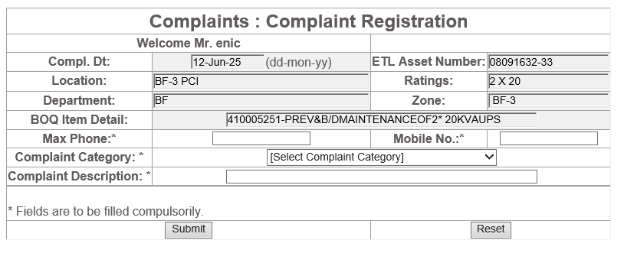

**Complaint Category:**

1. DC Over voltage
2. Inverter Overvoltage
3. Inverter Overload trip
4. Inverter Limb 1 or Limb2 fault - trip
5. CPU fault - trip
6. Over temperature trip
7. Alternate supply Under voltage
8. Alternate supply Over voltage
9. Alternate supply frequency out of sync limits
10. Static switch transfer to Alternate
11. MCB trip
12. Input Under voltage
13. Input Over voltage
14. Battery discharging
15. End of discharge
16. Inverter Under voltage
17. Inverter Overload
18. Others

**Preventive Maintenance:**

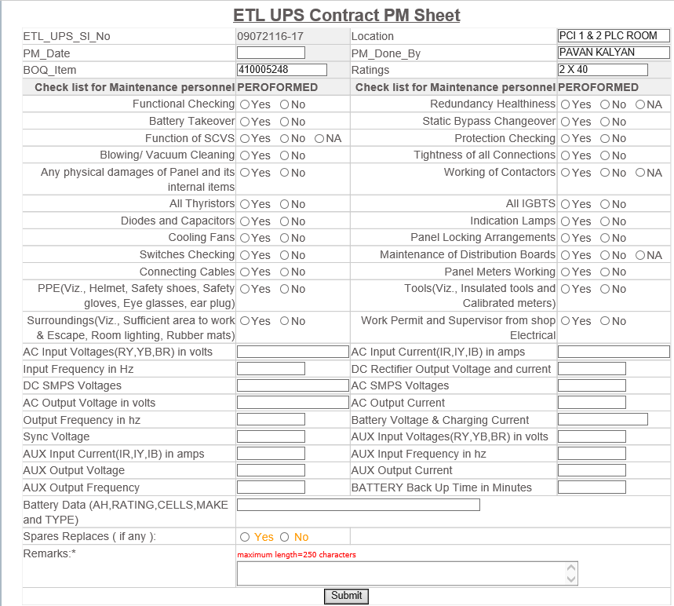

|  |  |
| --- | --- |
| **S.NO** | **PPM CHECK LIST** |
| 1 | Functional Checking |
| 2 | Redundancy Healthiness |
| 3 | Battery Takeover |
| 4 | Static Bypass Changeover |
| 5 | Function of SCVS |
| 6 | Protection Checking |
| 7 | Blowing/ Vacuum Cleaning |
| 8 | Necessary Checking |
| 9 | Checking for tightness of all Connections |
| 10 | Checking for any physical damages of Panel and its internal items |
| 11 | Working of Contactors |
| 12 | All Thyristors |
| 13 | All IGBTS |
| 14 | Diodes and Capacitors |
| 15 | Indication Lamps |
| 16 | Cooling Fans |
| 17 | Panel Locking Arrangements |
| 18 | Switches Checking |
| 19 | Maintenance of Distribution Boards |
| 20 | Connecting Cables |

**5. DESIGN OF PROJECT AND DATABASE SCHEMA**

* 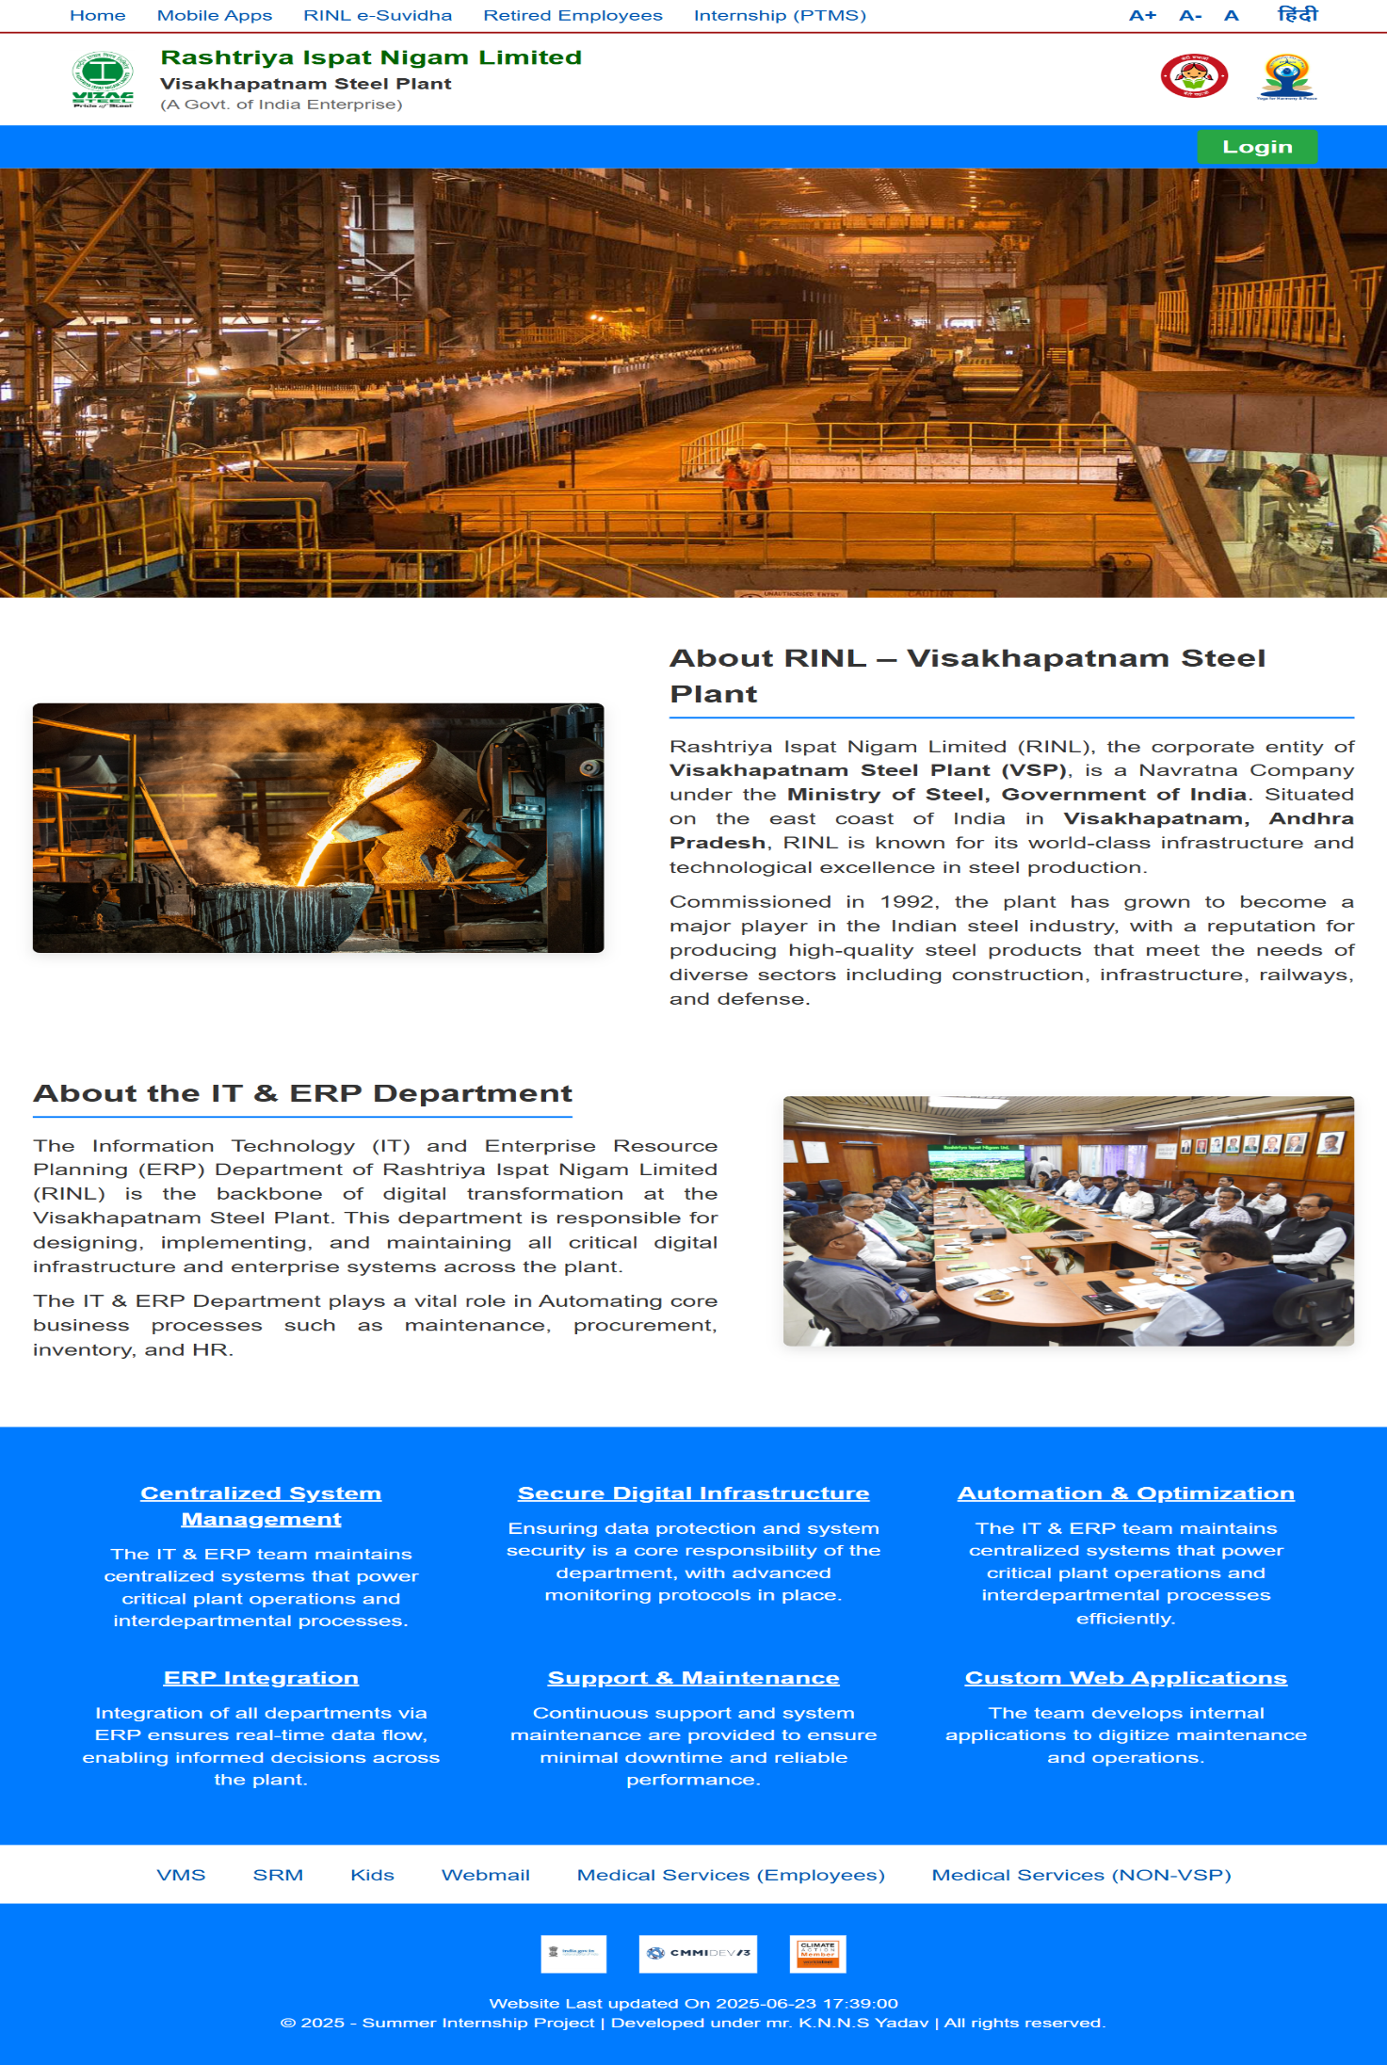**Homepage**
* **Login**

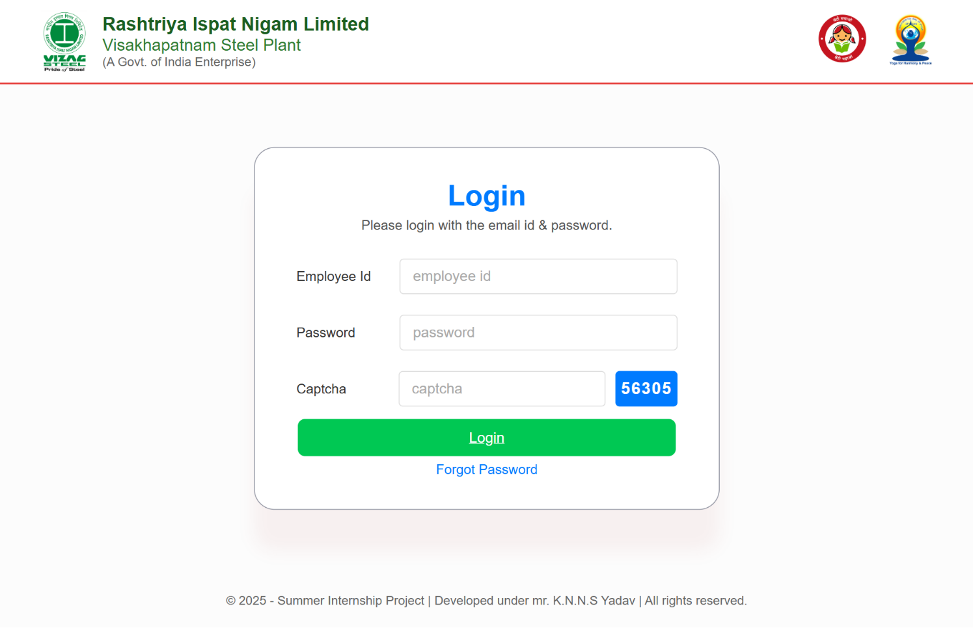

The login page provides secure access to the portal where each employee signs in using a unique employee ID and password. This ensures authorized access, protects system data, and allows users to perform role-specific tasks safely and efficiently.

* **Register complaints and Submit Preventive Maintenance Reports**

1. Register **UPS Complaints** – Used to report new UPS-related problems by entering issue details, location, and asset information for quick action.
2. View **UPS Complaints Reports** – Used to view all registered complaints, track their current status, and see actions taken for resolution.
3. Submit **Preventive Maintenance Reports** – Used by contractors to submit monthly UPS maintenance reports in digital format as per contract requirements.
4. View **UPS Preventive Reports** – Used by engineers and coordinators to review maintenance reports and verify maintenance activities.
5. View **UPS Preventive Reports Approval** – Used by authorized officers to approve, reject, or comment on preventive maintenance reports.

* **Register complaints and Submit Preventive Maintenance Reports**

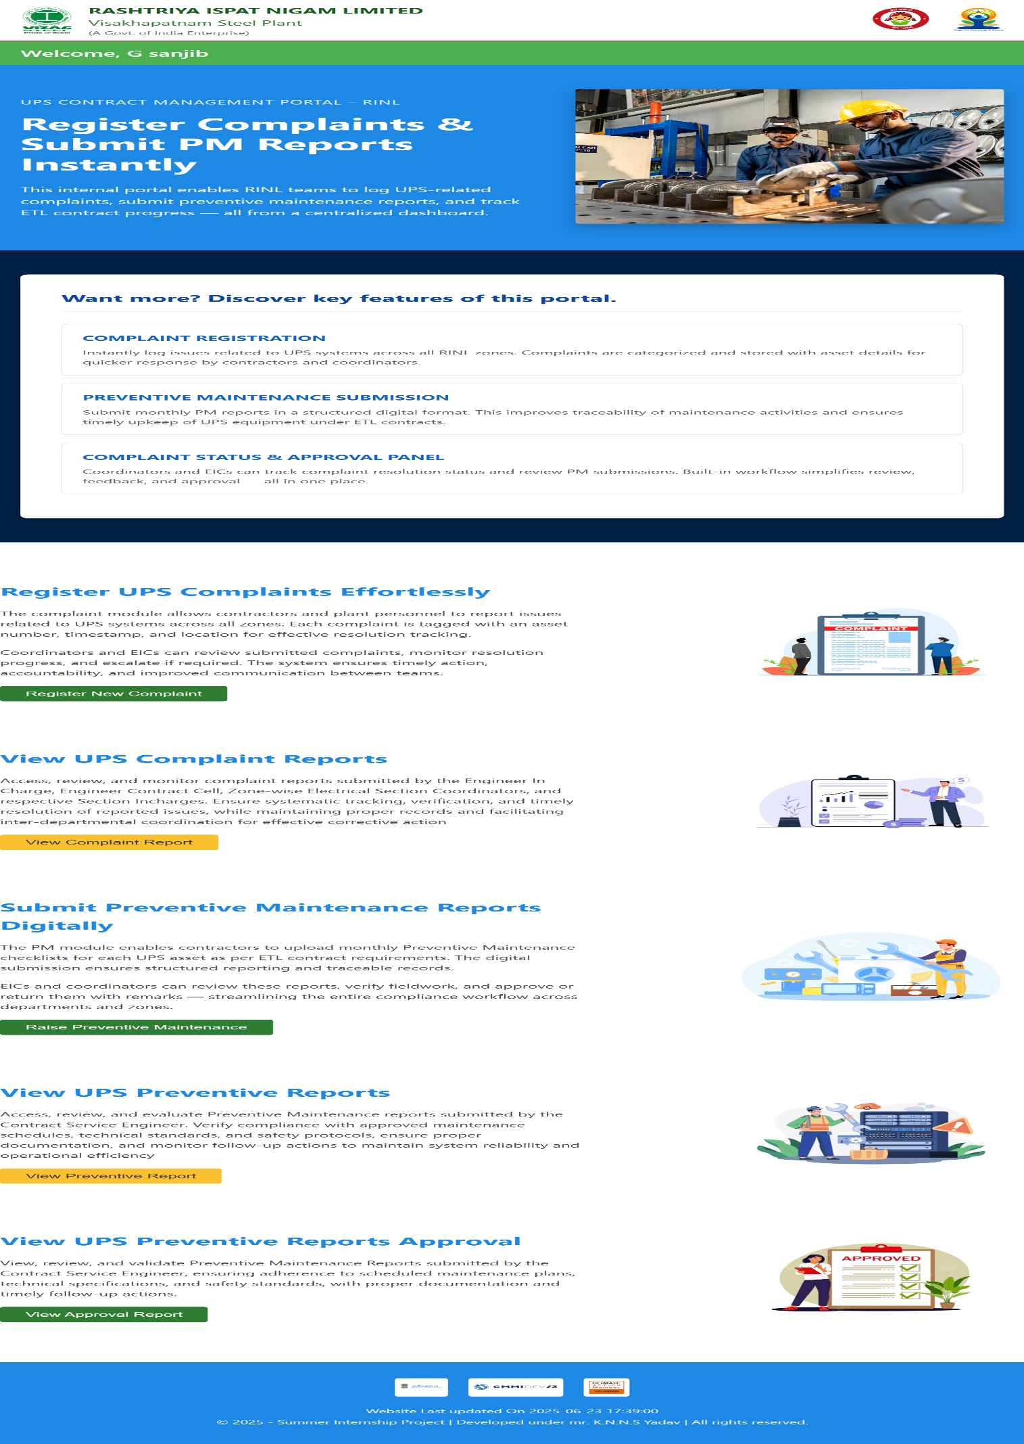

* **Complaint Registration**

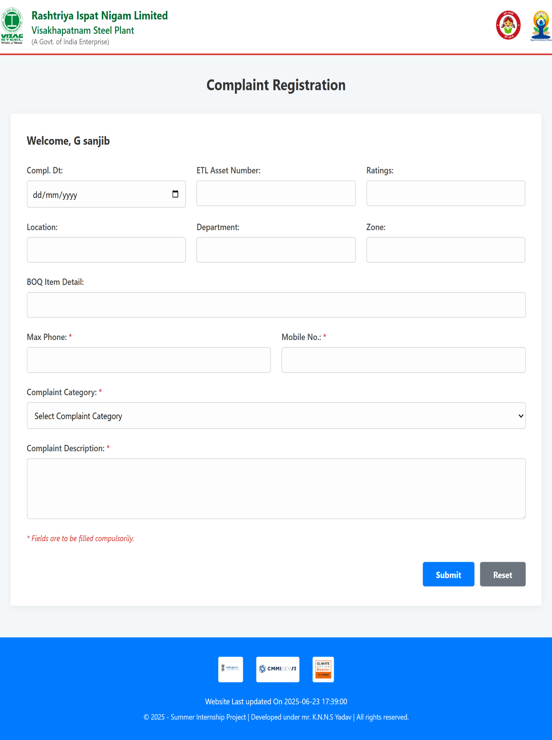

* **View UPS Complaint Reports**

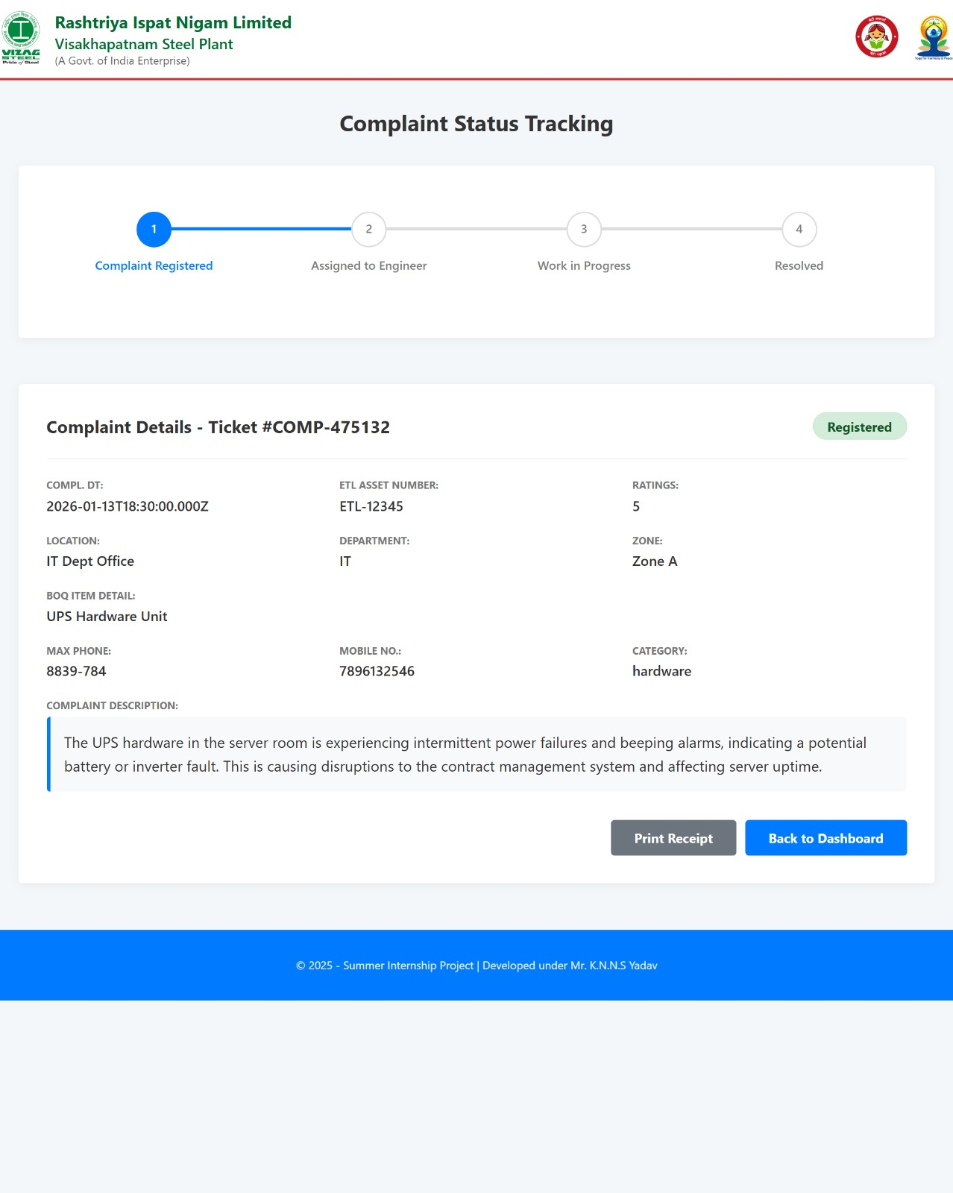

* 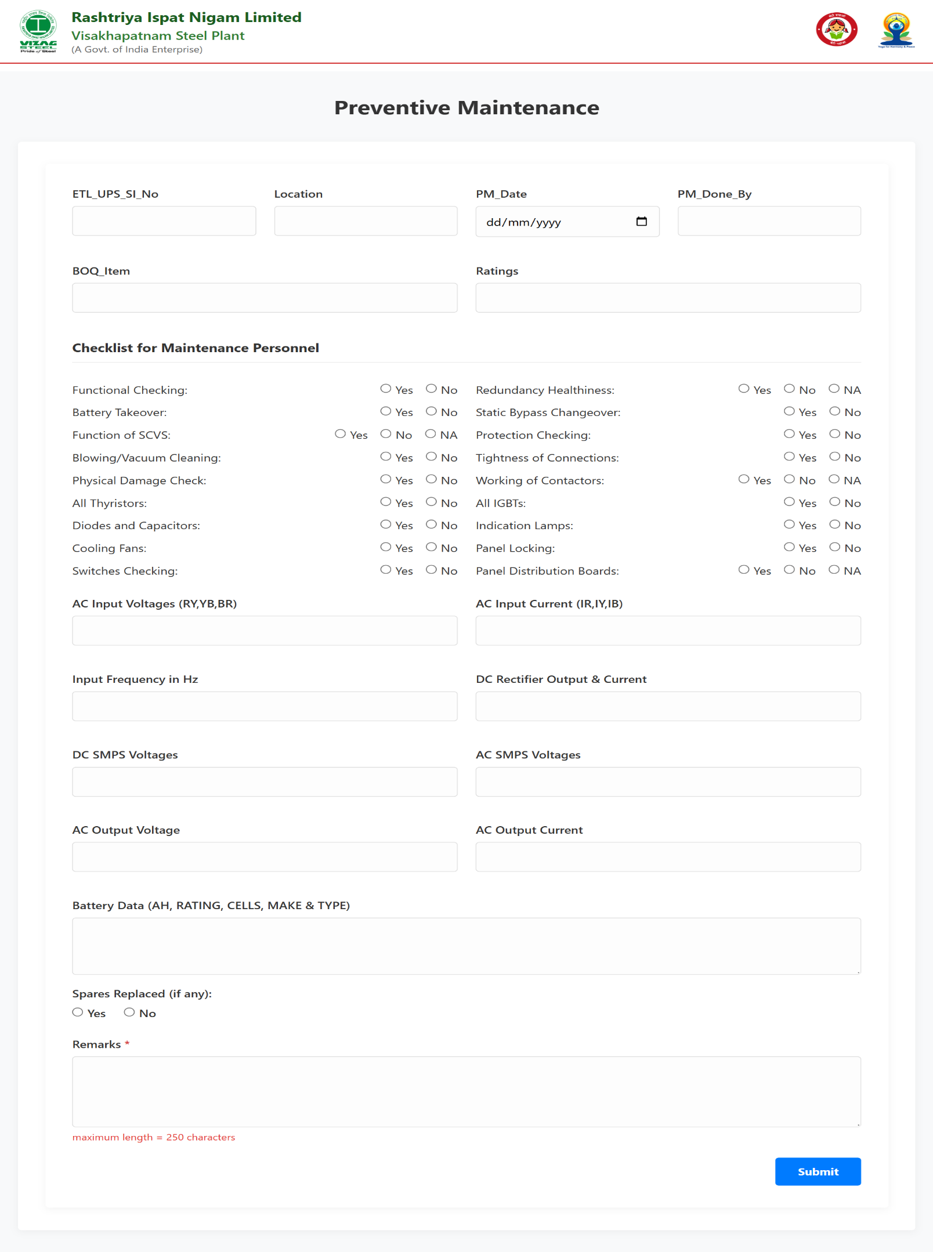**Preventive Maintenance Reports**
* **View UPS Preventive Reports**

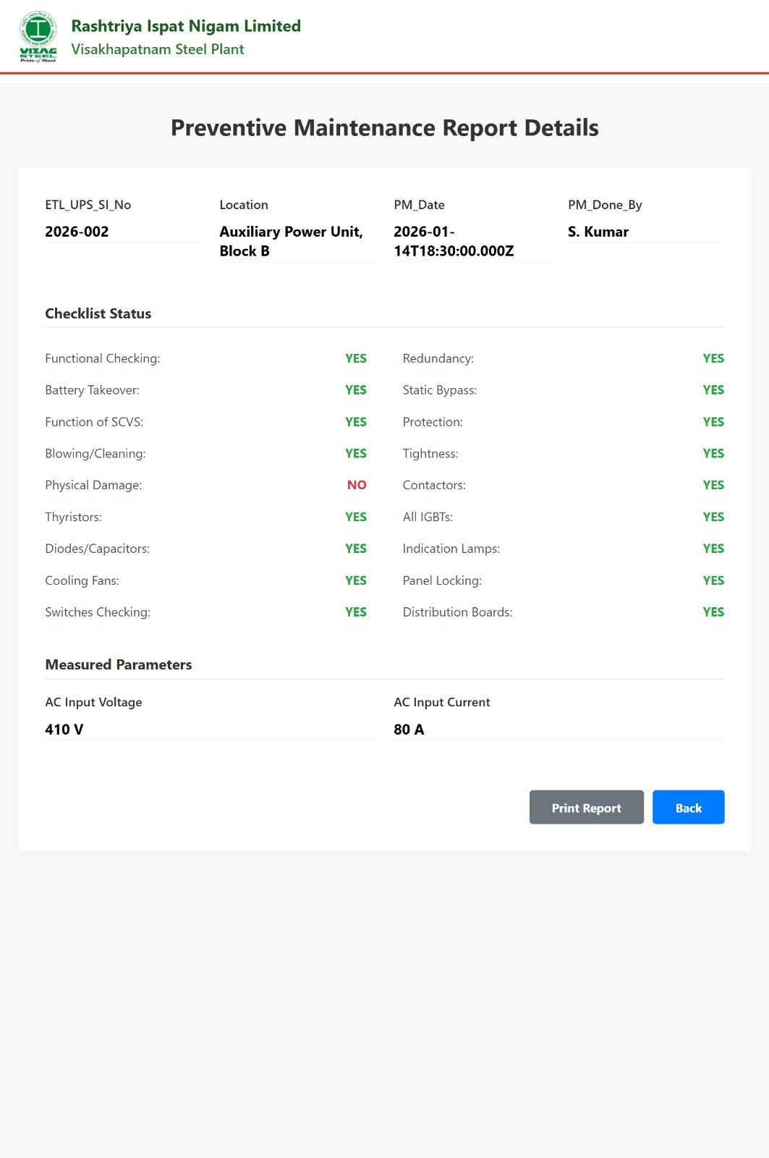

* **View UPS Preventive Reports Approval**

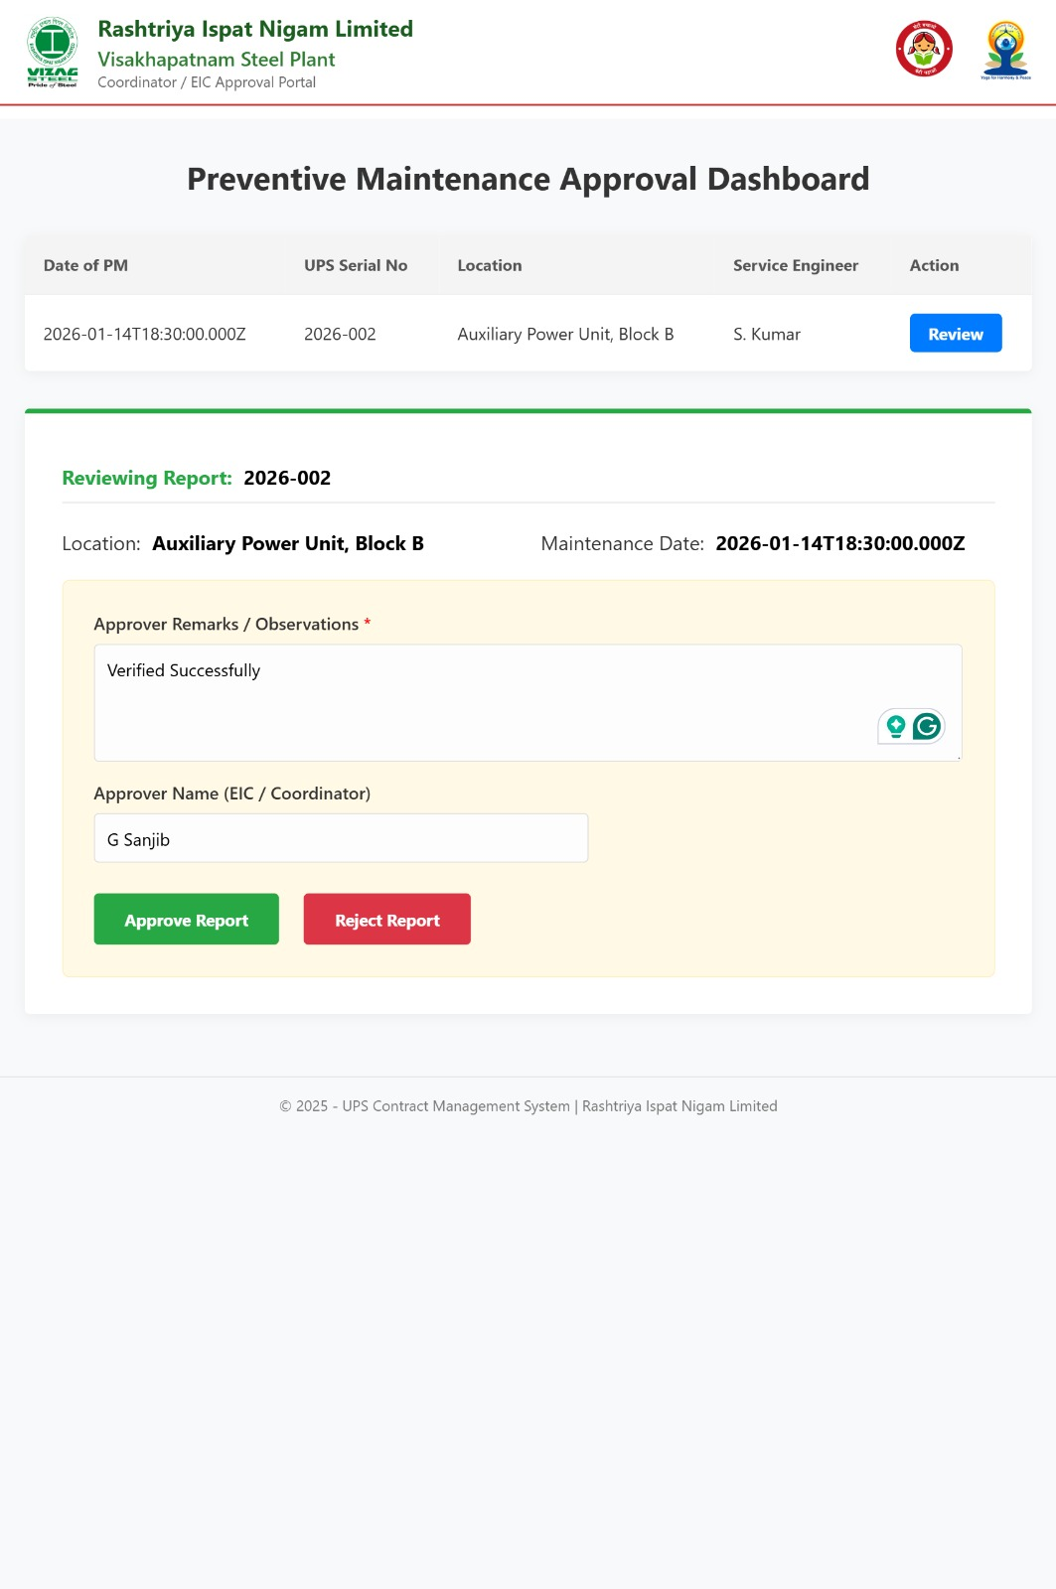

* 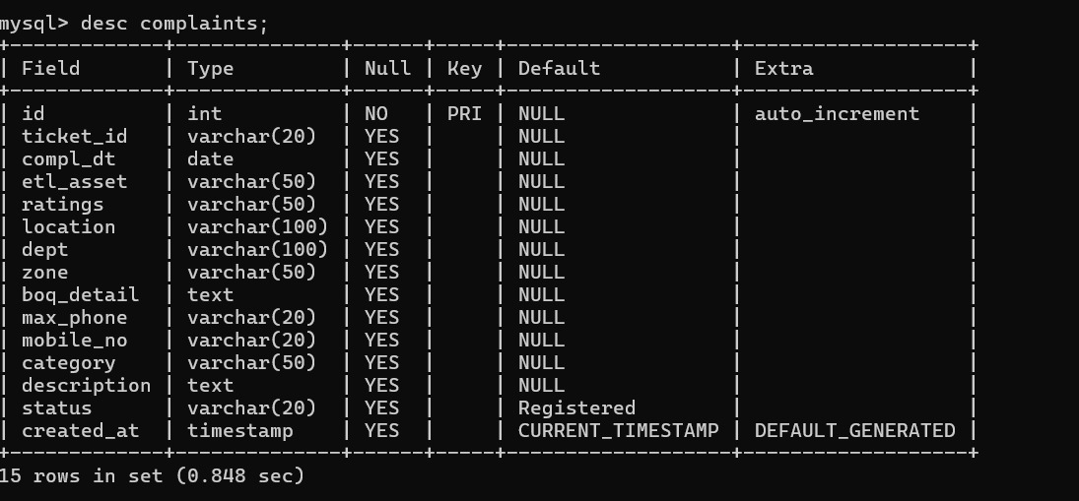**BACKEND AND DATABASE PHOTOS**

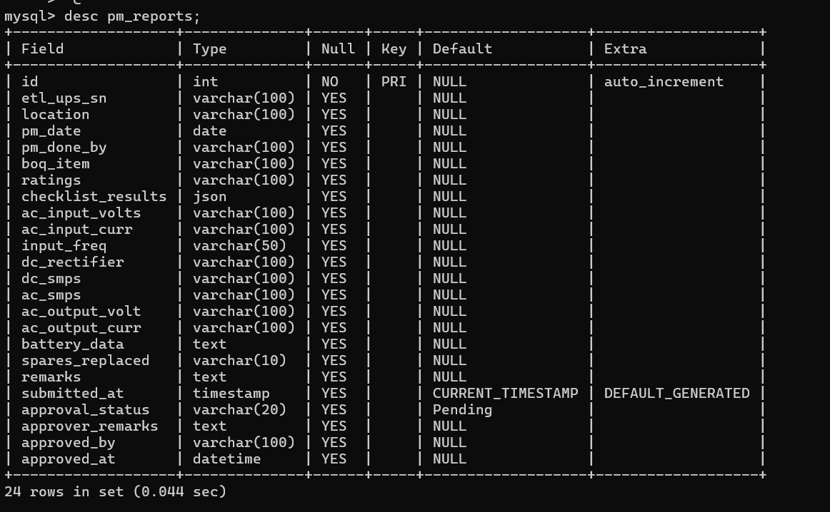

**7. CONCLUSION**

In conclusion, the **UPS Contract Management System** plays a vital role in **streamlining the management of UPS-related contracts, preventive maintenance schedules, and complaint handling processes** within an organization. By transitioning from manual logbooks to a centralized digital platform, the system enhances **data accuracy, operational efficiency, and transparency** across departments.

The system ensures that all maintenance activities and contract records are tracked in real-time, reducing delays and miscommunication. Features like **role-based access**, **status verification**, and **digital reporting** empower various stakeholders—such as CSE, ESC, ESI, CC and EIC—to perform their responsibilities seamlessly.

With automation and structured workflows, the platform not only **saves time and effort** but also lays the foundation for **scalable and efficient contract management**. As organizations grow and technology evolves, systems like this become essential in maintaining high standards of service, accountability, and documentation.

Overall, the **UPS Contract Management System** demonstrates how the integration of web technologies can significantly improve traditional workflows, promoting **efficiency, reliability, and digital transformation** within service-oriented sectors.

**8. REFERENCES**

# <https://www.npmjs.com/>

# <https://mongoosejs.com/>

# <https://nodejs.org/en>

# <https://developer.mozilla.org/en-US/docs/Web/HTML>

# <https://developer.mozilla.org/en-US/docs/Web/CSS>

# <https://www.vizagsteel.com/index.asp>